South Metropolitan TAFE

Munster Campus

Applied Engineering

AGV Mecanum Platform

P

Advanced Diploma in Engineering - Mechanical

|  |  |  |  |
| --- | --- | --- | --- |
|  | Author | Student Number (I.D) | Date |
| 1. | Bryce Richards | P136265 |  |
| 2. | Robert Williams |  |  |
| 3. | Cyprian Sino | P241310 |  |
| 4. | Gurkaran Singh |  |  |
| 5. | Purnima Samararatne |  |  |
| 6. | Zixiao Tang |  |  |
| 7. |  |  |  |

## Abstract

*In this section you are to write a brief summary of the report. The abstract should be:*

* *An appropriate length.*
* *A complete summary of key information.*
* *Informative, not descriptive, in form.*
* *Impersonal in tone.*
* *Written with connected prose.*

*Remove ALL italicised instructional text found in this document prior to submitting your assignment.*

Table of Contents

Abstract 2

Introduction 4

AGV Platforms 4

Design Concept 4

Problems associated with the design 4

Design Components & Material Selection 4

Mecanum Wheel 5

Frame 2

Lifting Mechanisms 2

Drive System 2

Control System 2

Calculations 3

Costings 3

Discussion and Conclusion 3

Recommendations 3

References 3

List of Figures 3

List of Tables 3

Appendix 3

## Introduction

*This section must address the following criteria:*

* *Relating topic to wider field.*
* *Necessary background information.*
* *Purpose of report.*
* *Scope of report.*
* *Explanation of arrangement of report.*
* *Sections.*

Written by Bryce Richards.

In the manufacturing industry the use of automation is growing, especially in the world’s industrialised societies. This is largely due to the ever-increasing labour cost in these areas of the world. Equipment components are typically referred to as ‘automated’ because they perform their operations with a reduced level of human participation compared with the corresponding manual process. In some highly automated systems, there is virtually no human participation.[1]

Common benefits of industrial automation include:

* Increased labour productivity
* Reduced labour cost
* Mitigated effects of labour shortages
* Reduction/elimination of routine manual and clerical tasks
* Improved worker safety
* Improved product quality
* Reduced manufacturing lead time
* Accomplishment of processes that cannot be done manually
* Competitive advantage

The purpose of this report is to detail the collaborative design project performed at South Metropolitan TAFE over the 2017-2018 period. This project was focused on design of an AGV platform for use on campus. The report will describe what AGV Platforms are, the design concept for the project, design problems and their solutions, and the design process itself. It will finish with a discussion of the final state of the project and recommendations for future work.

## AGV Platforms

*This section should give an explanation of what AGV platforms are, how they operate, their uses, how they’re powered, lift capacities, price ranges, etc.*

Written by Bryce Richards.

AGV platforms are a branch of automatically guided vehicles commonly used in industrial environments. These platforms are typically rectangular, and have an integrated lifting mechanism used for ‘work-in-process’ movements. Work-in-Process movement is an application wherein AGV’s can be used to move material from the warehouse to production/processing lines or from one process to another.[2] A typical AGV platform is rated for a low maximum payload relative to its size, is powered electrically via on-board batteries, and with prices ranging up to $30,000USD for units capable of lifting 500kg.[3]

## Design Concept

*This section should give an outline of the criteria from which the design was based.*

*Eg. lift capacity, speed limits, overall size, standards, etc. Be thorough in this section.*

Written by Bryce Richards.

The Mecanum AGV will be capable of automatically transporting a lab from the storage room to the fluids laboratory, or from the fluids laboratory to the storage room. There will be a number of specified pickup and set-down locations in each room. A user will select a ‘From’ and ‘To’ location and the Mecanum AGV will transport the lab accordingly.

Design criteria were as follows:

* Maximum dimensions will be 795mm(W) x 800mm(L) x 250mm (H)
* Maximum rated capacity of the Mecanum AGV will be 1000kg
* Maximum speed of the Mecanum AGV will be 3kmph
* The maximum exposed incline on which the Mecanum AGV will operate will be 1°
* The maximum lift height of the Mecanum AGV will be 100mm
* The location Mecanum AGV will be accurate to +/-25mm

All technical drawings will be to AS1100.

## Problems associated with the design

*In this section, discuss any issues or problems that were associated with the initial design and who they were resolved.*

*Eg. Client amendments, lift mechanism problems, wheel/roller issue, off-the-shelf parts availability, etc.*

Written by Bryce Richards and Robert Williams.

Client amendments were a major problem during the project. These were difficult to manage as the original project team did not develop a formal scope document or Gantt chart. These changes included:

* Change to maximum payload from 500kg up to 1000kg
* Changes in scope to the operating environment of the AGV
* Late addition of IP65 requirement (waterproofing)

Lack of administrative project management was a problem. As above, the original project team did not develop a formal scope document or Gantt chart. These were developed in the 16th week of the project, at which point these were developed and rolled out.

## Design Components & Material Selection

*In this section, discuss how you went about the design from initial brain storming, sketching, etc. through to the finished part/assembly. Be sure to include any sketches, images and notes that are relevant to the part. Discus any events that may have had an impact on the final design outcome, eg. High cost of initial design, availability of material, etc. Be sure to include your material selection criteria.*

*This section should be a compilation of individual work, that is, each student should only write about the parts they were involved with and any other team member that may have contributed to your design. Be sure to include any relevant specifications such as weight, dimensions, power, etc.*

### Mecanum Wheel

*Rollers, Cheek Plates, Hub, Bearings, Axles, Urethane..*

*Place content here.*

Roller designed by Robert Williams

Hub designed by Cyprian Sino

Cheek Plates, Hub and Axles designed by Bryce Richards. Written by Bryce Richards.

CHEEKPLATE.ipt

Design of the mecanum wheel itself took 13 weeks. Many designs were tested to ensure a ‘bumpless’ rotation. The typical mecanum wheel is designed with small gaps or height differential between rollers. This results in vibrations whilst driving, reducing equipment life and increasing operation noise. We elected to create a design with minimal/no vibration due to this design element. The initial scope was for a wheel with 6 rollers, 200mm diameter, 22mm bearings.

Ross Jarvis instructed us that there must be a minimum of 5mm clearance between rollers. Based on this we confirmed that the maximum roller diameter would be 56mm. This also locked in the 6 roller maximum. I have inserted an Inventor sketch below illustrating the geometry of these issues / decisions.

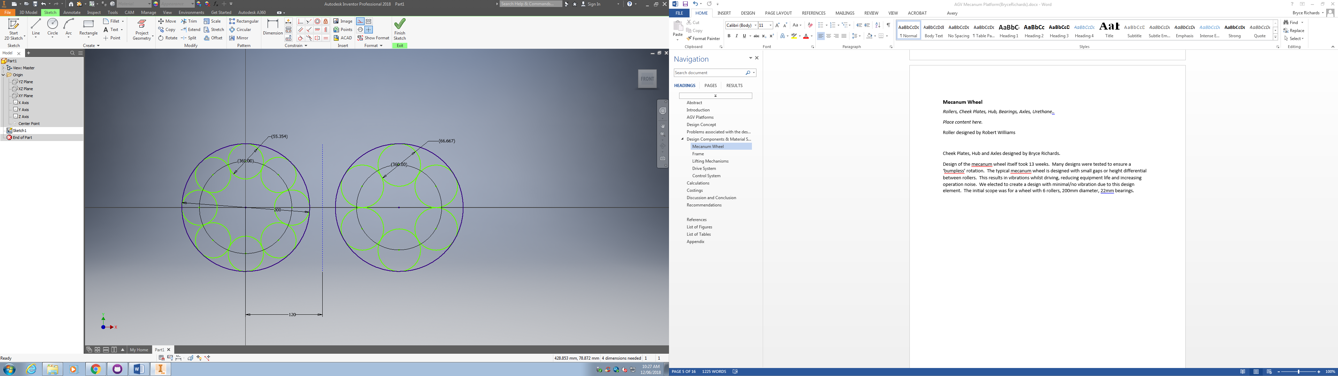

Following this I arrayed the 6 rollers at the design angle of 45° at a diameter which would effect a resultant 200mm as per the original scope.

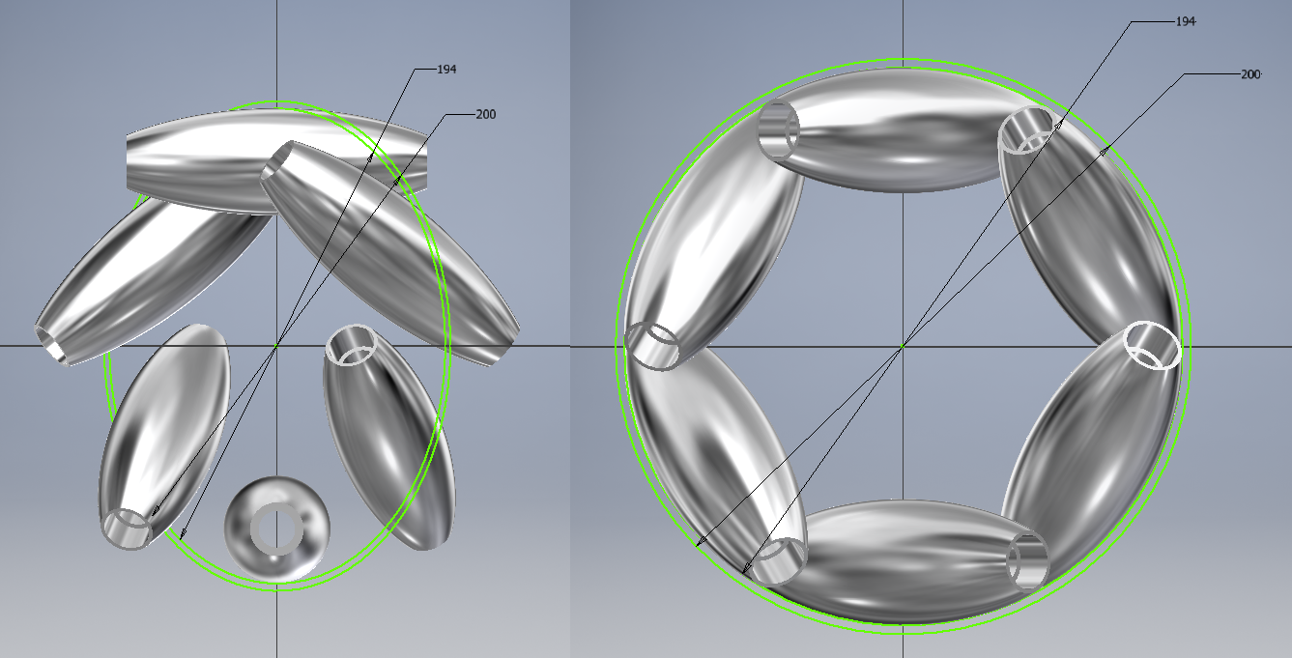

I then applied the Polyethylene cover to the rollers to get a final shape on the array.

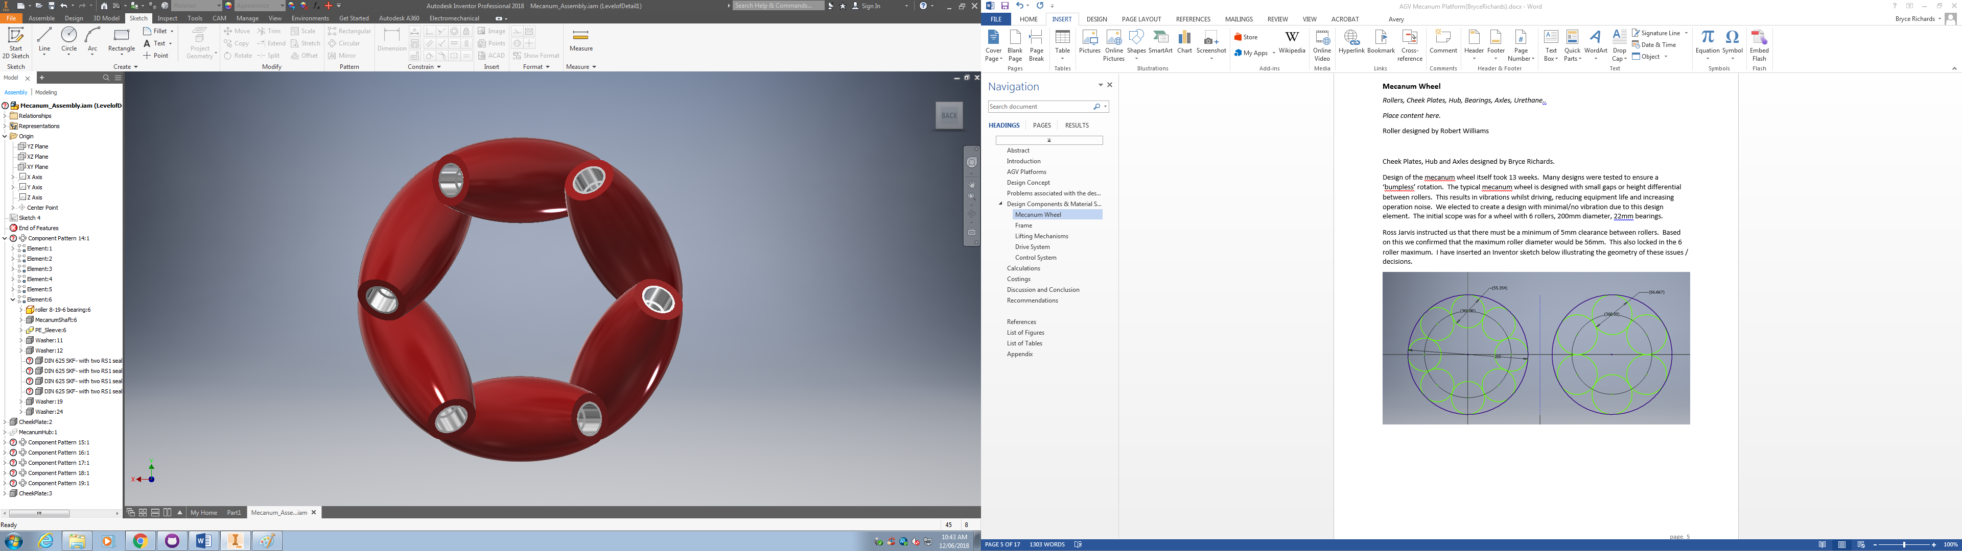

Next I checked with Adam Fiannaca (lecturer) and the thickest available aluminium plate would be 20mm. I superimposed a 20x200mm rectangle over the design to basically sight whether this was feasible for use in the cheekplate design. It was (not that the centreline of all shafts is basically contained within the green rectangles) so I proceeded to design the cheek plates.

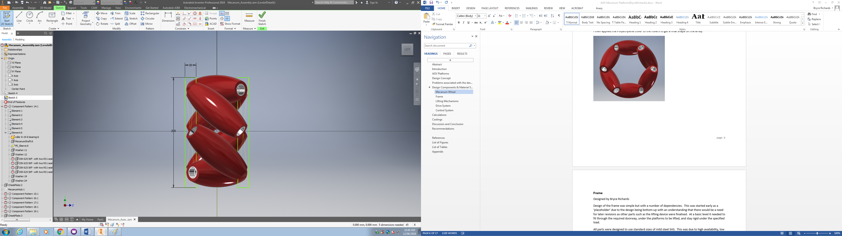

I then saved the above assembly and started a new *derived* part. The idea was similar to how I set up the rectangles in the above diagram. Now that we knew where the rollers would sit, build a circular plate in-context then cut out the shape of the rollers from that plate. This would ensure that everything remained aligned (as the geometry of the design was quite complex). As per the below I created an offset plane 50mm out from the XY plane (no real science, looked about right by eye, easy to move later provided I keep the design in-context). I then drew the 194mm circle on this plane (diameter of the rollers without polyethylene covers) and extruded to a total width of 20mm, centre-out. This created overlap between the rollers and the new plate which could be cut out of the plate later.

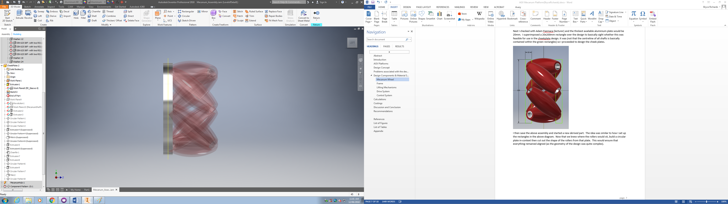

This next part was more complicated as I needed a plane down the middle of an angled roller offset from the centre of the planespace. I created a custom work plane on the face of the roller. By picking a roller which coincided with the Y axis this let me then create a midplane between the custom plane and Y axis. This plane was aligned with the centre of the roller.

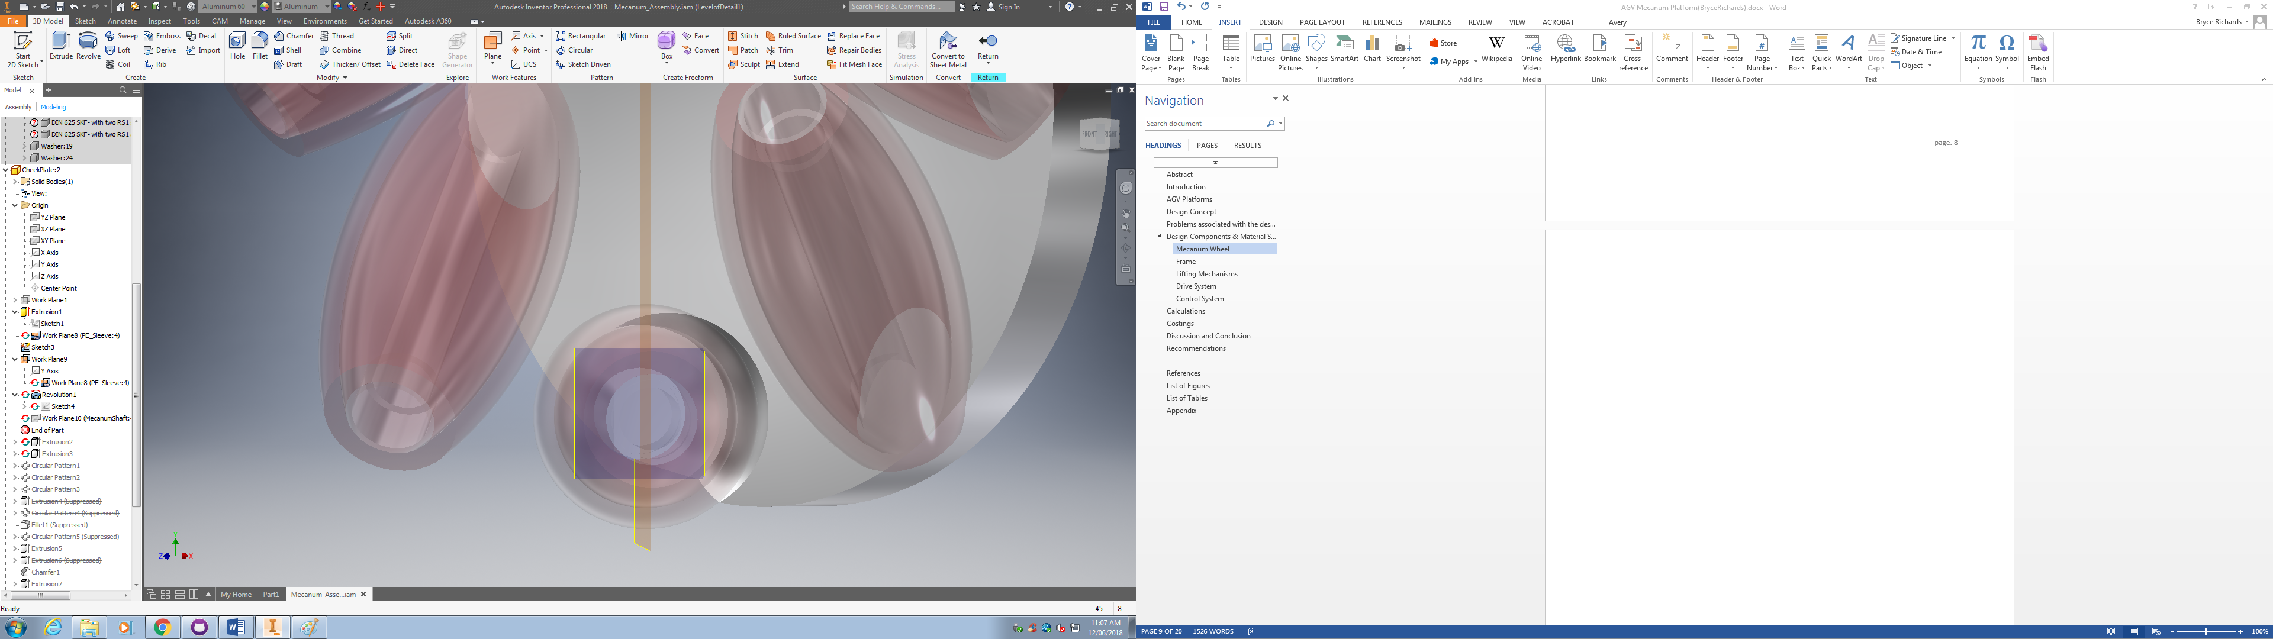

Next I drew the shape to cut out of the plate. This needed to be based on the geometry of the roller but with adequate clearance so that the roller could rotate inside of this cavity and not jam if small rocks or debris were to be caught. We held discussions with Adam Fiannaca and Ross Jarvis relating to this element of the design and we decided that 5mm of clearance along the curved surface and 1mm clearance on the face would be sufficient. I projected the polyethylene cover, offset that curve, and then made the requisite changes to create a fully contained polygon.

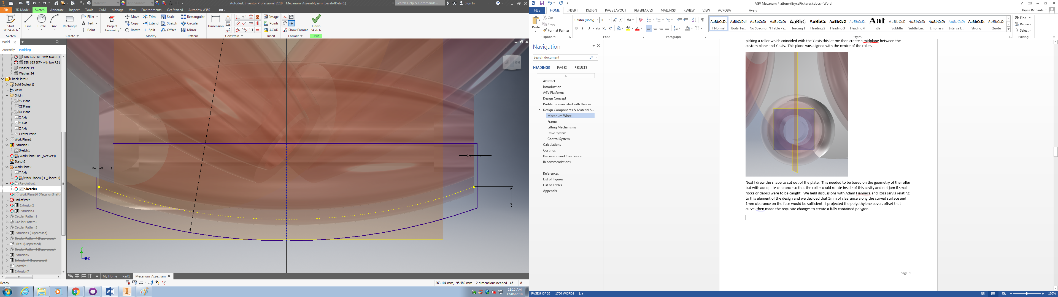

I then used the revolution tool to cut this shape out of the plate.

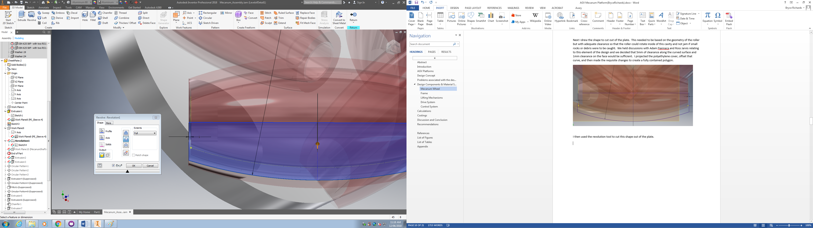

Next I offset the earlier custom plan out an arbitrary distance, drew a shape aligned to the roller axle, then extrude-cut back in to create a surface on which we could place a nut to secure the roller shaft.

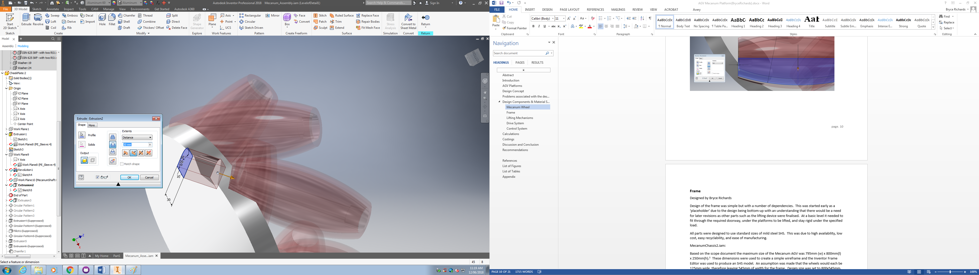

I now used the circular pattern tool to create 6 of both cuts aligned to the face of each roller. The circle was the 194mm original plate extrusion.

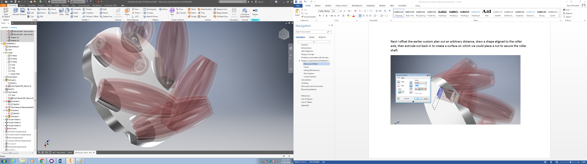

Finally I added mounting holes for the hub, a keyhole for the main axle, chamfers and radius as required. This concluded the design of the check plate. I also produced 2D drawings for quotation purposes.

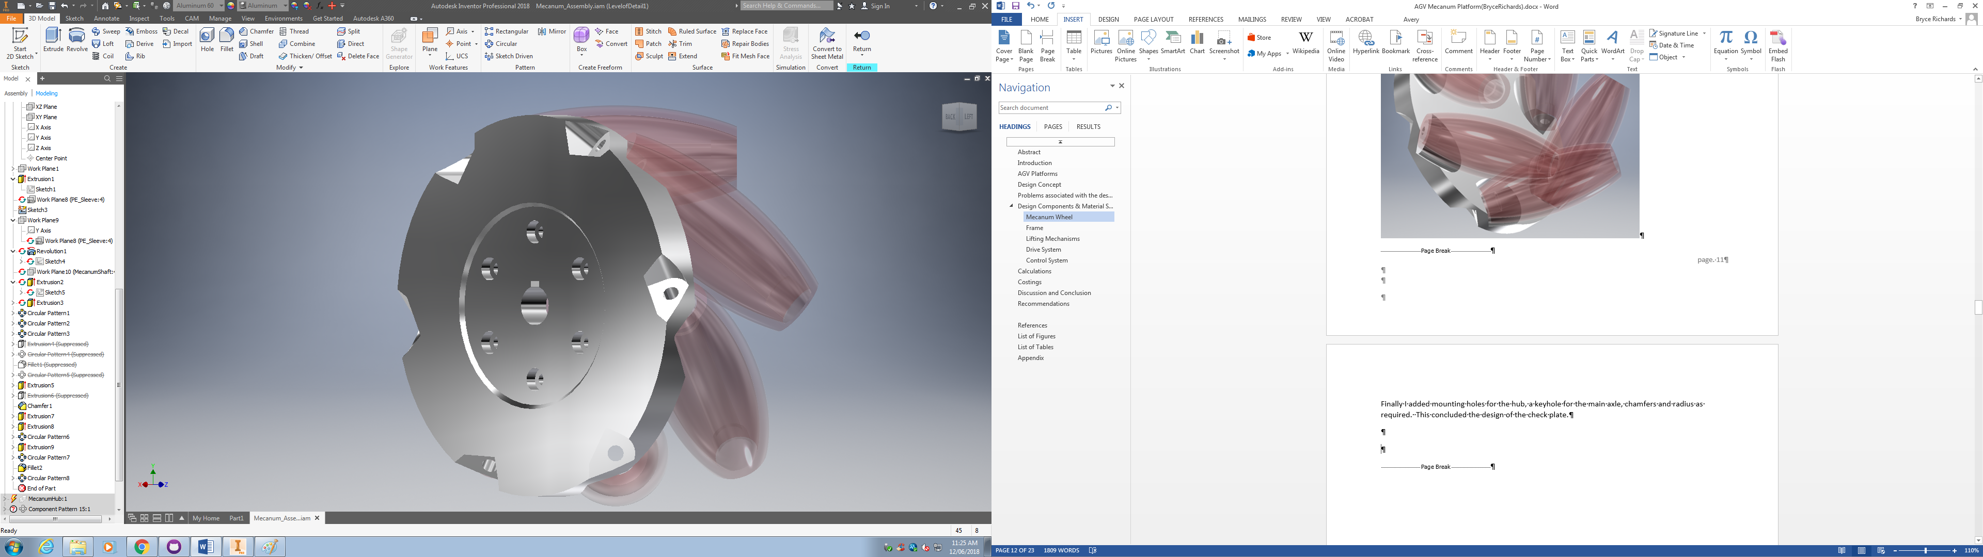

FIGURE A: CHEEKPLATE.dwg



### Frame

Designed by Bryce Richards

Design of the frame was simple but with a number of dependencies. This was started early as a ‘placeholder’ due to the design being bottom-up with an understanding that there would be a need for later revisions as other parts such as the lifting device were finalised. At a basic level it needed to fit through the required doorway, under the platforms to be lifted, and stay rigid under the specified load.

All parts were designed to use standard sizes of mild steel SHS. This was due to high availability, low cost, easy recyclability, and ease of manufacturing.

MecanumChassis2.iam:

Based on the scope document the maximum size of the Mecanum AGV was 795mm (w) x 800mm(l) x 250mm(h).[4] These dimensions were used to create a simple wireframe and the Inventor Frame Editor was used to produce an SHS model. An assumption was made that the wheels would each be 125mm wide, therefore leaving 545mm of width for the frame. Design size was set to 800x545mm. Initially 45x45x1.6mm SHS was selected. An iterative process was used via which a size of SHS was selected, tested in the ‘Frame Analysis’ environment, then revised accordingly. The process repeated until a final selection was made of 35x35x1.6mm SHS which could tolerate the 500kg load with < 300MPa stress.

Two changes were necessary to the frame as the project progressed:

1. Once the design for the wheel hub was finalised it became apparent that the full 545mm was not available. The width of the frame was therefore reduced to 515mm to allow space for outboard nuts on the axle.
2. Late in the project Ross revised the scope up from a 500kg maximum payload to 1000kg maximum payload. Due to this it was necessary to increase the SHS thickness to 3mm.

LiftPlate.iam:

The lift plate followed the basic design of the chassis described above including late-stage reductions in width and increases in thickness. Design of this part was ultimately dependent on the lifting mechanism. The size of the gearbox for the lifting device determined the final size of the lifting plate – this caused the team to move the position of the legs of the lift plate to align with this device.

Following the above a group of 2D drawings were produced for fabrication. These were of the top and bottom of the chassis, and then the lifting plate (see figures A, B and C). These 2D drawings were used to cut and weld the selected 35x5x3mm SHS as required.

Cutting SHS to length:

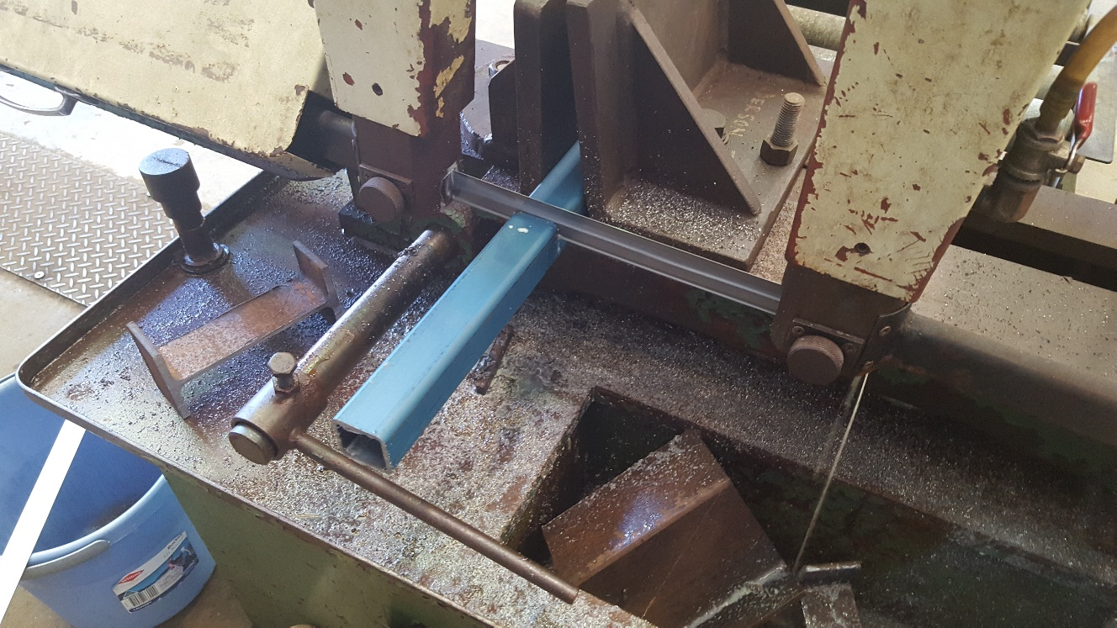

Cutting SHS 45° angles:

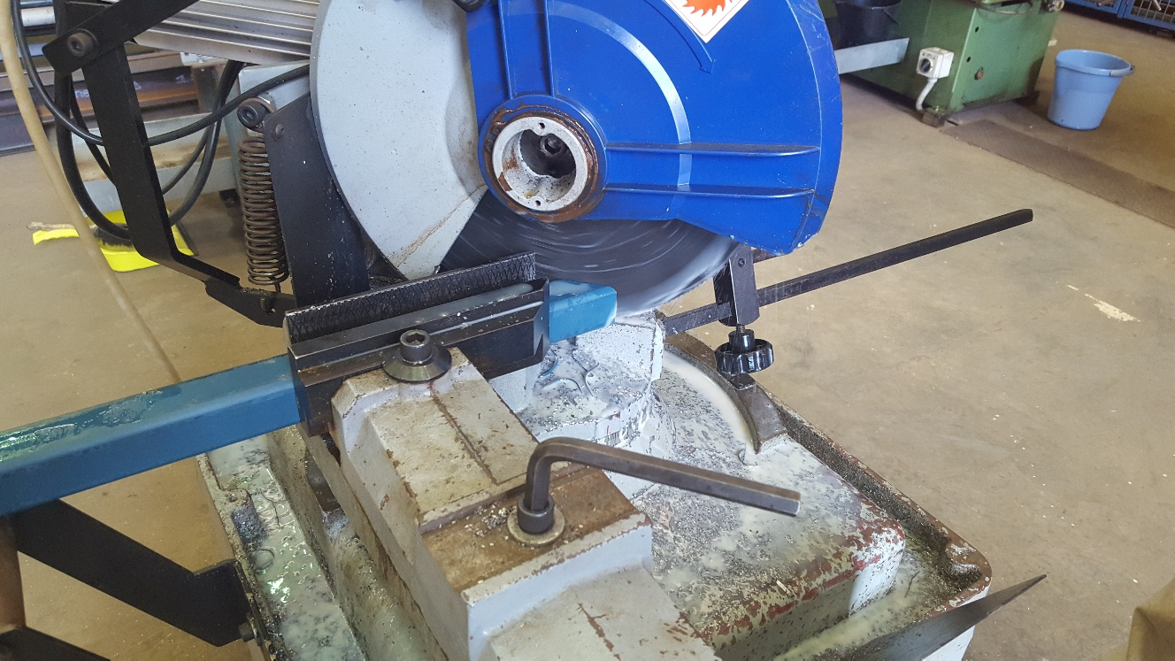

Preparation for welding SHS:

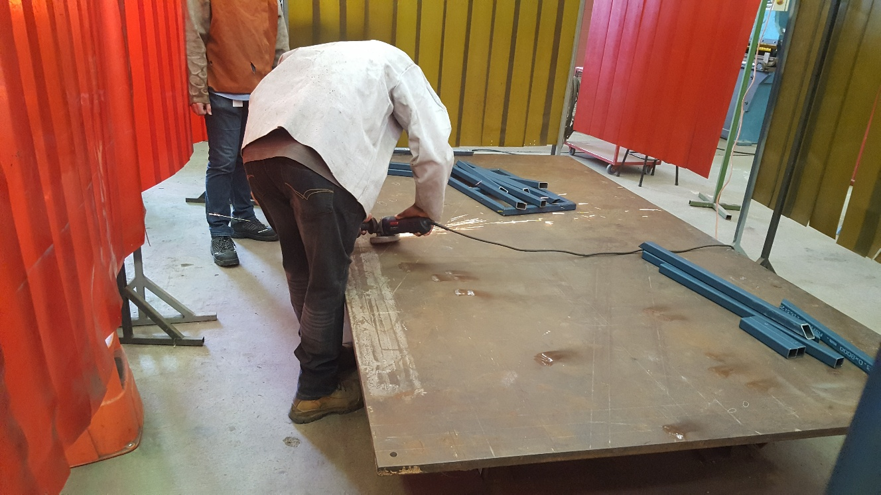

Top frame welded:

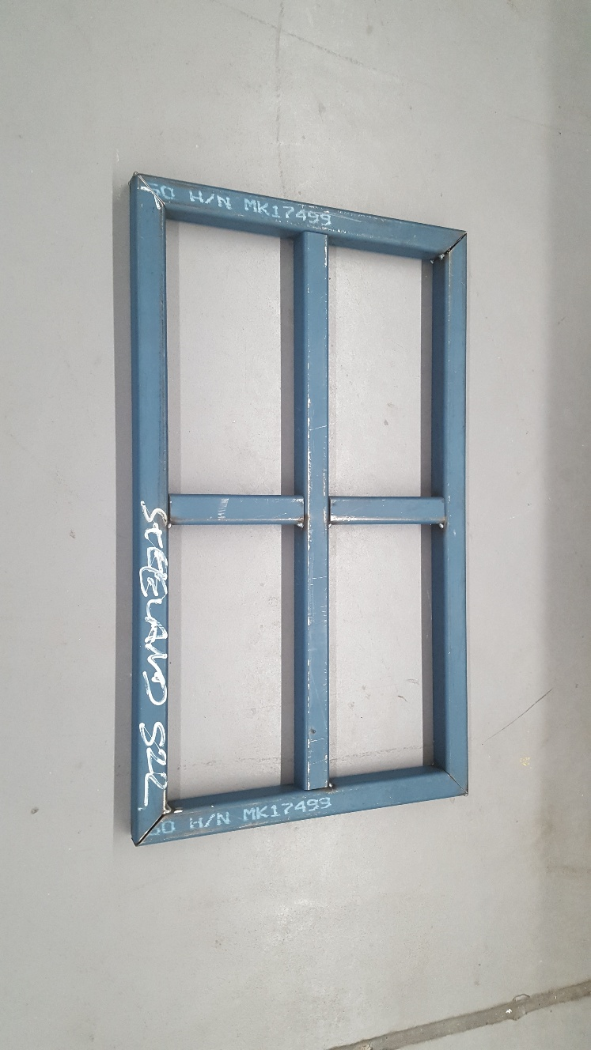

Base frame welded:

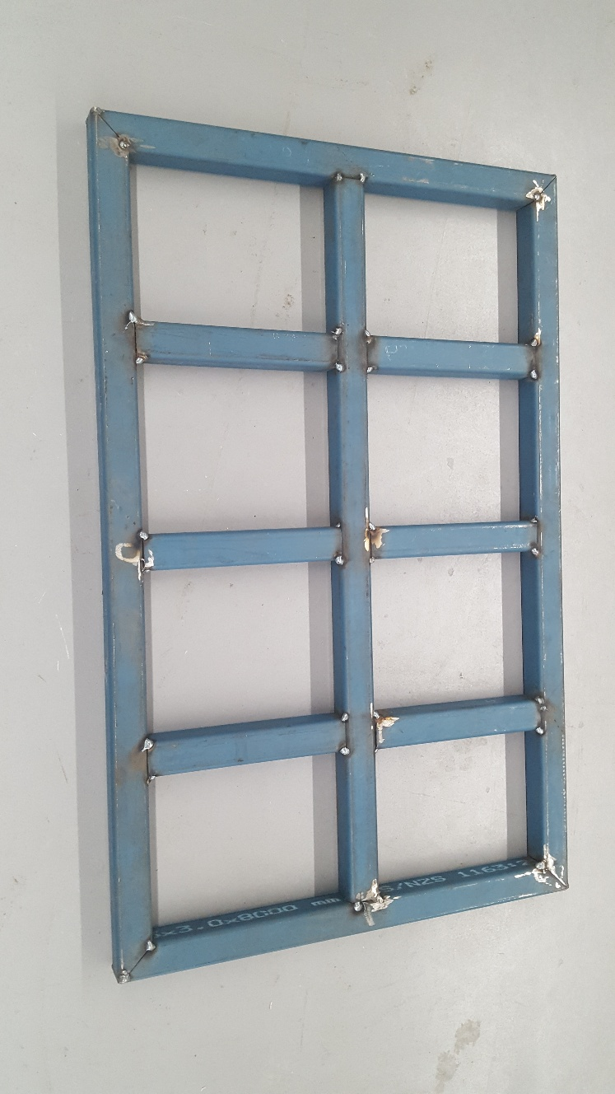

Figure A: MECANUM_BASE1.dwg

Figure B: MECANUM_BASE2.dwg

Figure C: MECANUM_TOP.dwg

**Drive System**

**Synchronous Pulleys and belts**

Designed by Cyprian Sino.

The design required for us to look into getting a small compact set of pulleys and belt with enough grit to move the AGV vehicle carrying 500kg upwards, so using the initial calculation on the excel chart on GitHub l set out to draw and produce an assembly which would fit on the already finished frame without moving the motor or wheels. The (f, x) parameter table below is the one l used to design synchronous pulleys. The user parameters helped draw a different size by just inputting numbers in the equation.

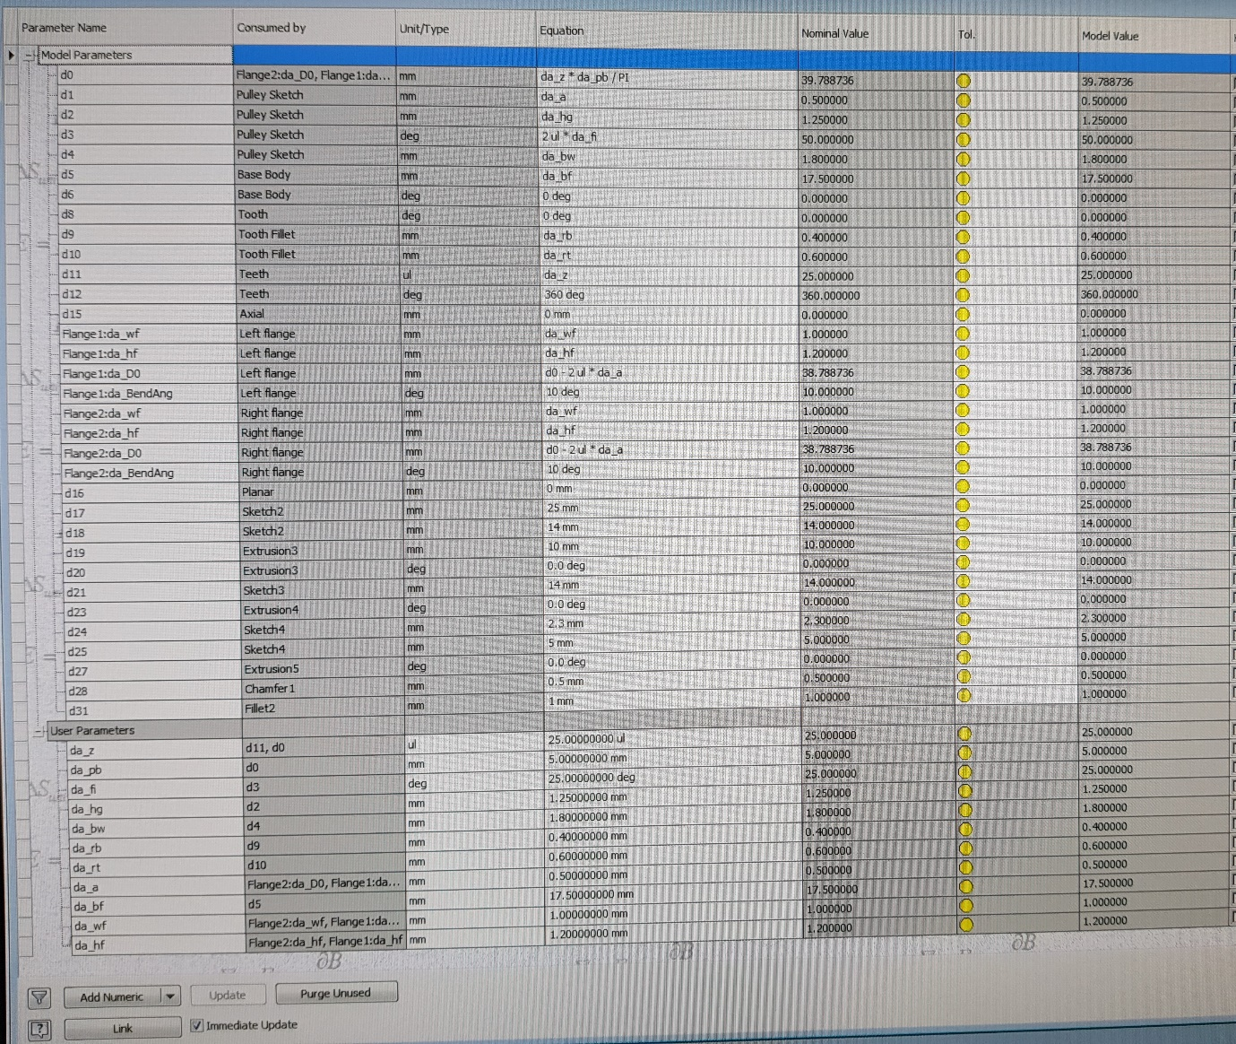

### Lifting Mechanisms

*Electro-mechanical: Gearbox, motor, ball screw, bearings, linear rail, etc.*

*Place content here.*

Designed by Bryce Richards.

The design of an electro-mechanical lifting system was iterative, due to issues such as parts availability and prohibitive costs. Initial part selection was of a screw jack. These are pre-fabricated worm-gears with integrated ball screws and lifting devices. They are used commonly in industry for high-precision positioning of heavy loads. Unfortunately these proved to be prohibitively expensive in the sizes we were looking for as they are simply not a common component (use case is very small). Price of the E-Series PowerJacks[5] model was quoted at $2154.89 each[6], or $8619.56 for the set of 4 required for the design. Due to this we elected to not use an off-the-shelf component and design a device ourselves.

We had a group discussion (Bryce Richards, Robert Williams, Adan Fiannaca) regarding design of a custom lifting device. It was decided that we would use a worm gear (i.e. 90° gearbox) mated to a ball-screw. We had a maximum design height of 160mm and needed an effective lift height minimum 75mm.

Initially we looked at an inline coupling to a gear shaft. We selected a Ruland MCLX12-12-F[7] for this purpose, but ultimately the coupled design proved larger than 160mm so we moved to a through-shaft design.

We looked at a variety of worm gears such as the Ketterer Worm Gear[8], and the PBX-081[9], before ultimately deciding on the TIDEFEEL TS-58GZ868D[10]. This selection was due to the very low purchase price ($54USD) and simple design. Our intent was to remove the OEM output shaft and replace it directly with a machined ball screw.

### Drive System

*Motors, Shafts, bearings, axles, pulleys, belts, brackets, etc.*

*Place content here.*

### Control System

*Motor controllers, electronics (sensors, encoders), etc.*

*Place content here.*

## Calculations

*This section should show all calculations carried out for each component as well as the operation of the platform including any FEA, shear force diagrams, bending moment diagrams, excel sheets, hand written calculations, weld calculations.*

*Eg, speeds, forces, moments, torque, deflection, etc.*

*This section should also include the total weight of the platform.*

## Costings

*This section should outline all costs associated with the project. Be sure to include any quotes for materials, machining, off-the-shelf items, etc.* (p. 1)

## Discussion and Conclusion

*In this section, discuss the viability of your design in terms of the total cost involved, whether your objectives were met, client expectations, etc.*

At the end of the defined project period we had not completed the design. The mechanical design is mostly finished but some small elements such as linear rails and IP65 enclosures have not yet been selected. Additionally the electronics like sensors, limit-switches and micro-controllers have not been selected. Also the program has not been written due to the lack of electronic components.

Mechanically the design will lift the required loads. It is much smaller than comparable commercial units, and also has a production cost of <$8k, whereas commercial units will cost up to $30k and not be small enough for the intended use-case.

## Recommendations

*In this section, discuss any recommendations you may have to further improve your design, manufacturing processes, materials, and handing the project over to a third party, any experience you have gain that may be beneficial, etc.*

Details on the state of the project are articulated above. The next step should be selection of suitable rectangular rail and working these in to the FinalAssembly.iam assembly. Space is available but may require design changes to the frame to accommodate.

## 

## References

APA referencing style

## List of Figures

## List of Tables

|  |  |
| --- | --- |
|  |  |

## Appendix

1. EEP. (2016, January 11). 9 Reasons For Automation Of Manufacturing Processes | EEP. Retrieved June 19, 2018, from <http://electrical-engineering-portal.com/9-reasons-for-automation-of-manufacturing-processes>
2. Material & Work-in-Process Movement. (2009, March 18). Retrieved from <http://www.jbtc.com/automated-systems/products-and-applications/applications/material-and-work-in-process-movement>
3. Automatic Material Transport Agv Robot Price - Buy Agv Robot Price,Automatic Material Transport,Material Transport Agv Product on Alibaba.com. (n.d.). Retrieved June 19, 2018, from <https://www.alibaba.com/product-detail/Automatic-material-transport-agv-robot-price_60719093453.html?spm=a2700.7724857.main07.80.322f1943C21lp8>
4. Richards, B. (2017). *Scope Statement – Mecanum AGV Project: Project Description*
5. Power Jacks. (n. d.). E-Series Powerjacks: Metric Machine Screw Jack
6. Richards, B. (2018). ScrewJackQuote: Final Response
7. Ruland Couplings. (n. d.). MCLX /MSPX MCLC/MSPC
8. T.E.A. Transmissions. (2010). Ketterer Worm Gear. Retrieved June 19, 2018, from <https://www.tea.net.au/Product-Category-Modules/Specific_Product/product/Ketterer-Worm-Gear-/prodid/184/cid/19>
9. KHK Gears. (n. d.). PBX: Miniature Bevel Gearboxes. Retrieved June 19, 2018, from <https://khkgears.net/pdf/pbx.pdf>
10. TSINY. (n. d.). TS-58GZ868. Retrieved June 19, 2018, from [www.tsinymotor.com/uploads/soft/140520/1-1405201J956.pdf](http://www.tsinymotor.com/uploads/soft/140520/1-1405201J956.pdf)